**Foundations of Deep Learning – Homework Assignment #2**Adi Album & Tomer Epshtein

**Part 1: (2)**

Question:  
Prove that with polynomial width $\overline{B}$ the deep network cannot realize all possible functions. In particular derive an exponential in $d$ lower bound on $\overline{B}$ required in order for its hypothesis space to be $y^{X}$.

Solution:

Denote by ${\overline{H}}_{\overline{B}}$ the class of functions realizable by deep AND-OR networks with width $\overline{B}$ (as defined in class). We will prove that ${\overline{H}}_{\overline{B}}≠y^{X}$ by combinatorial reasoning for $\overline{B}∈O(poly\left(d\right))$. And that for ${\overline{H}}_{\overline{B}}=y^{X}$ we need $\overline{B}$ to be exponential in $d$.

$\left|y^{X}\right|={\left|y\right|}^{\left|X\right|}=2^{2^{d}}$

$\left|{\overline{H}}_{\overline{B}}\right|=?$

$$\left|{\overline{H}}_{\overline{B}}\right|≤\#\{Parameter combinations in AND-OR deep nets of width \overline{B}\}$$

Let’s count the number of parameter combinations. Reminder:

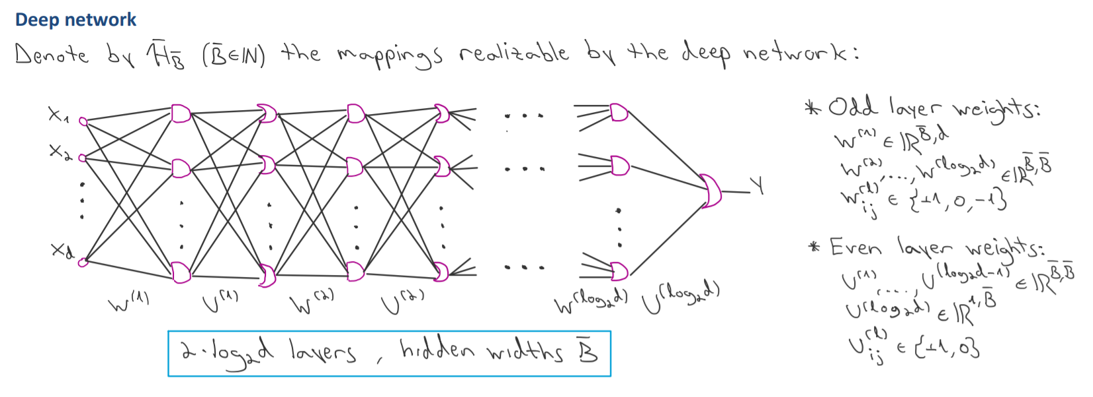

* $W^{(1)}$ has $\overline{B}×d$ parameters from $\{-1,0,+1\}$, yielding: $3^{\overline{B}×d}$ combinations
* $W^{(j)}$ has ${\overline{B}}^{2}$ parameters from $\{-1,0,+1\}$, for $j∈\left\{2,…,\log_{2}\left(d\right)\right\}$, yielding: $3^{\left(\log_{2}\left(d\right)-1\right)×{\overline{B}}^{2}}$ combinations
* $U^{(\log_{2}{(d}))}$ has $\overline{B}$ parameters from $\{0, +1\}$, yielding: $2^{\overline{B}}$ combinations
* $U^{\left(j\right)}$ has ${\overline{B}}^{2}$ parameters from $\{0,+1\}$, yielding: $2^{\left(\log_{2}\left(d\right)-1\right)×{\overline{B}}^{2}}$ combinations.

Bringing it all together:

$$\left|{\overline{H}}_{\overline{B}}\right|≤3^{\overline{B}×d}×3^{\left(\log_{2}\left(d\right)-1\right)×{\overline{B}}^{2}}×2^{\overline{B}}×2^{\left(\log_{2}\left(d\right)-1\right)×{\overline{B}}^{2}}$$

Let $\overline{B}∈O\left(poly\left(d\right)\right)$.

$\left|{\overline{H}}_{\overline{B}}\right|≤3^{\overline{B}×d}×3^{\left(\log_{2}\left(d\right)-1\right)×{\overline{B}}^{2}}×2^{\overline{B}}×2^{\left(\log_{2}\left(d\right)-1\right)×{\overline{B}}^{2}}=3^{d\overline{B}+\left(\log_{2}\left(d\right)-1\right){\overline{B}}^{2}}2^{\overline{B}+\left(\log_{2}\left(d\right)-1\right)×{\overline{B}}^{2}}≤$

$≤4^{d\overline{B}+\left(\log_{2}\left(d\right)-1\right){\overline{B}}^{2}}4^{\overline{B}+\left(\log_{2}\left(d\right)-1\right)×{\overline{B}}^{2}}=4^{d\overline{B}+\left(\log_{2}\left(d\right)-1\right){\overline{B}}^{2}+\overline{B}+\left(\log_{2}\left(d\right)-1\right)×{\overline{B}}^{2}}=$

$4^{(d+1)\overline{B}+2\left(\log_{2}\left(d\right)-1\right){\overline{B}}^{2}}\overset{(*)}{≤}4^{\left(d+1\right){\overline{B}}^{2}+2\left(d+1\right){\overline{B}}^{2}}=4^{3\left(d+1\right){\overline{B}}^{2}}=2^{6\left(d+1\right){\overline{B}}^{2}}$

(Where $(*)$ holds because $\overline{B}≤{\overline{B}}^{2}$, $\log_{2}{(d)}-1≤d+1$, and monotonicity of $x↦4^{x}$)

For any $\overline{B}∈O\left(poly\left(d\right)\right)$: $2^{6\left(d+1\right){\overline{B}}^{2}}=2^{O\left(poly\left(d\right)\right)}$ 
 and in particular $2^{6\left(d+1\right){\overline{B}}^{2}}<2^{2^{d}}$ so $\left|{\overline{H}}_{\overline{B}}\right|<|y^{X}|$.  
So, ${\overline{H}}_{\overline{B}}≠y^{X}$ 
for $B∈O(poly\left(d\right))$*.*

We will now derive an exponential lower bound for $\overline{B}$ for us to achieve ${\overline{H}}_{\overline{B}}=y^{X}$.

We saw

$$\left|{\overline{H}}_{\overline{B}}\right|≤2^{6\left(d+1\right){\overline{B}}^{2}}$$

For ${\overline{H}}_{\overline{B}}=y^{X}$ we must have

$$2^{6\left(d+1\right){\overline{B}}^{2}}≥2^{2^{d}}$$

$⟹$ $6\left(d+1\right){\overline{B}}^{2}≥2^{d}$ $⟹$ ${\overline{B}}^{2}≥\frac{2^{d}}{6(d+1)}$.

So for ${\overline{H}}_{\overline{B}}=y^{X}$, we must have ${\overline{B}}^{2}≥\frac{2^{d}}{6(d+1)}$ And in particular $\overline{B}≥\frac{2^{\frac{d}{2}}}{\sqrt{6\left(d+1\right)}}$.

An exponential in $d$ lower bound on $\overline{B}$, as desired.

$∎$